Software Requirements Specification

for

Car Accessories Store, Release 1.0

Version 1.0 approved

Prepared by Quy & Thuan

Process Impact

September 28, 2013

Table of Contents

Revision History ii

1. Introduction 1

1.1 Purpose 1

1.2 Document Conventions 1

1.3 Project Scope and Product Features 1

1.4 References 1

2. Overall Description 1

2.1 Product Perspective 1

2.2 User Classes and Characteristics 2

2.3 Operating Environment 3

2.4 Design and Implementation Constraints 3

2.5 Assumptions and Dependencies 3

3. System Features 3

3.1 Order Meals from Cafeteria 3

3.1.1 Description 3

3.1.2 Functional Requirements 3

3.2 Order Meals from Restaurants 5

3.3 Create, View, Modify, and Delete Meal Subscriptions 5

3.4 Create, View, Modify, and Delete Cafeteria Menus 5

4. Data Requirements 6

4.1 Logical Data Model 6

4.2 Data Dictionary 6

4.3 Reports 9

4.3.1 Ordered Meal History Report 9

4.4 Data Integrity, Retention, and Disposal 9

5. External Interface Requirements 10

5.1 User Interfaces 10

5.2 Software Interfaces 10

5.3 Hardware Interfaces 10

5.4 Communications Interfaces 10

6. Quality Attributes 11

6.1 Usability Requirements 11

6.2 Performance Requirements 11

6.3 Security Requirements 11

6.4 Safety Requirements 11

6.5 Availability Requirements 11

6.6 Robustness Requirements 11

Appendix A: Analysis Models 12

Revision History

|  |  |  |  |
| --- | --- | --- | --- |
| **Name** | **Date** | **Reason For Changes** | **Version** |
| Cao Hoàng Quy |  |  | 1.0 |
| Nguyễn Lê Thuần |  |  | 1.0 |

# Introduction

## Background

The Accessories Car Store manager spends a lot of time making statistics on store orders and sales over a period of time. Besides, it is also very difficult to manage and pay salaries for a large number of employees. They also do not have enough time to take care of Store customers because most of the time they have to manage other Store activities. The store will not be known by large numbers of customers. Checking the products' in-warehouse from the staff is quite complicated and time-consuming. The process of checking the status of products has to go through many steps. It is difficult for customers who live far away to access and purchase products. The process of buying a product takes a long time and is almost paid for directly at the store. That will bring many disadvantages to customers who are far away who want to buy products at the store.

## Business Opportunity

The customer requires a software system that allows users to easily manage their store. From employee management, salary payment to revenue management, customer statistics and orders in a period of time. Thereby the shop owner has more time to take care of his customers to help more people know the store. Information about the products will be stored in the database. Enable buyers to access and interact quickly as well as experience providers, in addition customers can pay online on the app. Track the shipping of the product. And receive automatic maintenance notifications.

## Business Objectives

BO-1: Increase 50% revenue in first 3 months of system release.

BO-2: After 6 months, 1 million customers will use product of company Accessories Car.

BO-3: Reduce store management costs after 6 months of app release:

- Reduce the number of warehouse and store managers.

BO-4: 100% increase in revenue in 12 months of app release.

## Success Metrics

< Determine how success will be defined and measured on this project, and describe the factors that are likely to have the greatest impact on achieving that success. Include things within the direct control of the organization, as well as external factors. Establish measurable criteria to assess whether the business objectives have been met.>

## Vision Statement

For customers who want to order accessories from the company Accessories Car or from local shop, the Accessories Car Ordering System is an Internet-based and smartphone-enabled application that will accept individual or an store orders and trigger delivery of the accessories to location of customers. Unlike the current telephone and manual ordering processes, customers who use the Accessories Car Ordering System will receive the product as soon as possible, which will save them time.

## Business Risks

<Summarize the major business risks associated with developing this product, such as marketplace competition, timing issues, user acceptance, implementation issues, or possible negative impacts on the business. Estimate the severity of the risks and identify any risk mitigation actions that could be taken.>

## Business Assumptions and Dependencies

AS-1: Systems with appropriate user interfaces will be available for Accessories Car employees to process the expected volume of meals ordered.

AS-2: Accessories will be prepared and delivered to the customer within 2 days of order.

DE-1: If the delivery location is too far (> 1000km), the delivery time may be more than 2 days.

# Scope and Limitations

<The project scope defines the concept and range of the proposed solution. It’s also important to define what will not be included in the product. Clarifying the scope and limitations helps to establish realistic expectations of the many stakeholders. It also provides a reference frame against which proposed features and requirements changes can be evaluated. Proposed requirements that are out of scope for the envisioned product must be rejected, unless they are so beneficial that the scope should be enlarged to accommodate them (with accompanying changes in budget, schedule, and/or resources).>

## Major Features

Manager:

- Invoice Management.

- Revenue statistics.

- Manage suppliers list

- Manage employee list.

Employee:

- Import and export products into the warehouse.

- Following the status of products in stock

- Provide system access through corporate intranet, smart phone, tablet, and outside internet access by authorized employees.

Customer:

- Order and pay for accessories from the store menu to be picked up and delivered.

- Order and pay for accessories from the local store.

- Create, view, modify, and cancel the product in shopping card will be buy.

- View information of list accessories from the store.

## Scope of Initial Release

|  |  |  |  |
| --- | --- | --- | --- |
| Feature | Release 1 | Release 2 | Release 3 |
| FE-1, Order from car accessories store. | *Product-for-delivery orders can only be paid for with a salary deduction.* | Accept credit and debit card payments | *Accept product order 24/7* |
| FE-2, Order from store offline. | Not implemented | *Delivery only when specific location information is available* | Fully implemented |
| FE-3, Product subscriptions | Not implemented | *Implemented if allowed by the provider* | Fully implemented |
| FE-4, Product lists | Create and view list | Modify, delete, and archive list |  |
| FE-5, Ingredient lists | Not implemented | Fully implemented |  |
| FE-6, System access | Intranet and outside Internet access | iOS and Android phone and tablet apps | Windows Phone and tablet apps |

## Limitations and Exclusions

LI-1: Some product items that are available from the car accessories will not be suitable for delivery, so the list of products available to patrons of the ACS must be a subset of the full product items of the car store.

LI-2: The ACS shall be used only for the car accessories store at the Ho Chi Minh city.

# Overall Description

## Product Perspective

Figure 1. Context diagram for release 1.0 of the Car Accessories Store.

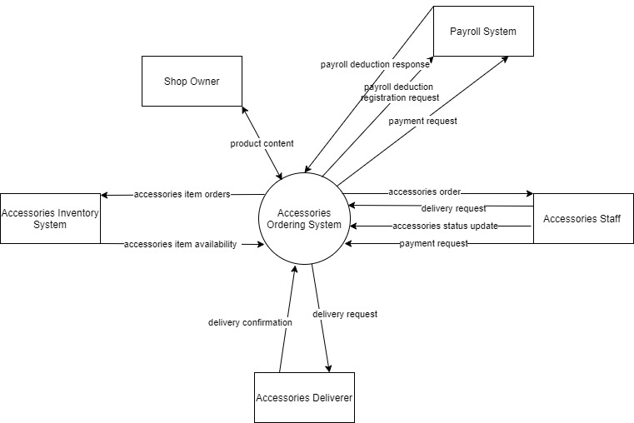

## User Classes and Characteristics

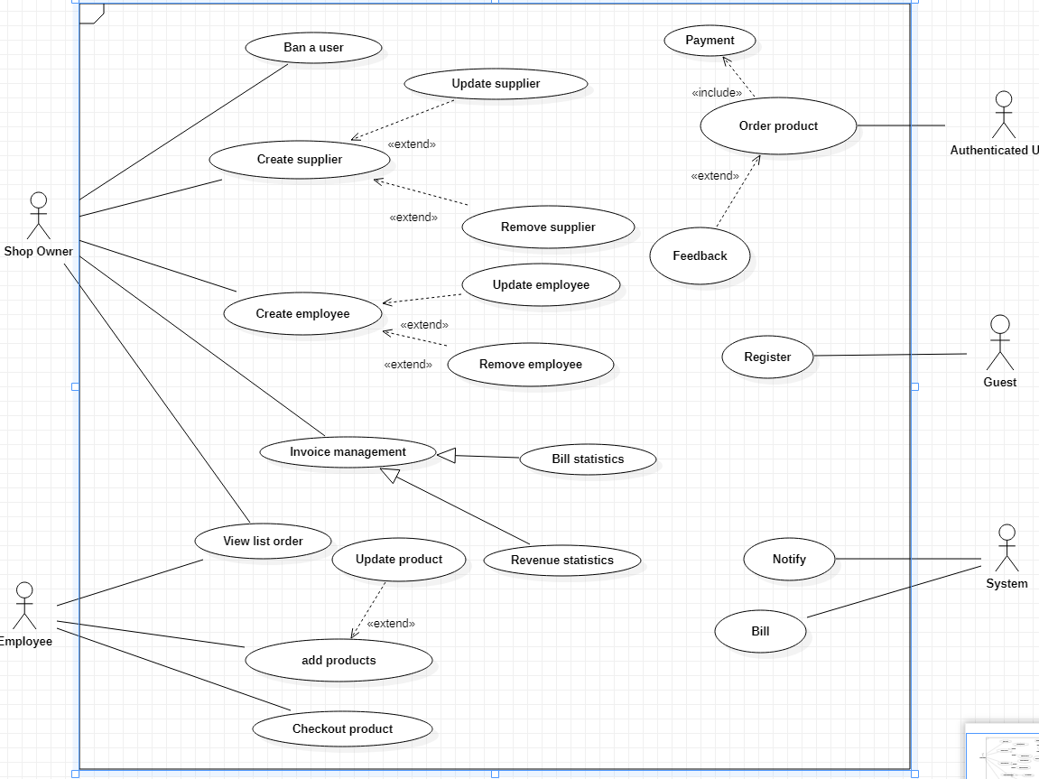

|  |  |  |  |
| --- | --- | --- | --- |
| UC ID and Name: | **UC-1 Order a Product** | | |
| Created By: | Quy & Thuan | Date Created: | 19/1/21 |
| Primary Actor: | Authenticated User | Secondary Actors: | Accessories Car System |
| Trigger: | An Authenticated User indicates that they wants to order a product | | |
| Description: | An Authenticated User access the Accessories Car System on the internet. View list product, selects items, fill in personal information, checkout and the product will be shipped to the customer. | | |
| Preconditions: | PRE – 1. User is logged into ACS | | |
| Postconditions: | POST-1. Product order is stored in ACS with a status of “Accepted”  POST-2. Inventory of available product is updated to reflect items in this order.  POST-3. User have an order on the ACS. | | |
| Normal Flow: | **1.0 Order a product**   1. User login into ACS. 2. ACS displays list of available product. 3. User selects one product from list product. 4. User goes to the shopping card. 5. ACS displays all the product information and price that user choice. 6. User confirms the product they selected. 7. User fills in personal information and delivery time and specifies the delivery location. 8. User confirms the order. 9. ACS makes order for user. | | |
| Alternative Flows: | * 1. **Order multiple products**  1. User wants to buy more products. 2. User will back to list of available product. 3. Return to step 2 of normal flow. | | |
| Exceptions: | 1. **E1 No delivery time left:** 2. The user cancels the order, then ACS terminates use case. | | |
| Priority: | High | | |
| Frequency of Use: | Approximately 500 users, average of one usage per day. The system works 24/24. | | |
| Business Rules: | BR-1. Order must be pay by Paypal or Momo e-wallet or internet banking.  BR-2. Order price is calculated as the sum of each accessories item price times the quantity of that item ordered, plus applicable sales tax(10%).  BR-3. If the total price of products is more than 1 million VND. The customer will be free to ship.  BR-4. Customers are only allowed to buy maximum 100 products.  BR-5. Customers are only allowed to choose 1 location to receive the products. | | |
| Other Information: | 1. User shall be able to cancel the product ordering process at any time prior to confirming it. 2. User shall be able to view all products he ordered within the previous six months and repeat one of those products as the new order. (Priority = M) | | |
| Assumptions: | Assume that 15 percent of Patrons will order the monthly special | | |

|  |  |  |  |
| --- | --- | --- | --- |
| UC ID and Name: | **UC-1 Revenue statistics** | | |
| Created By: | Quy & Thuan | Date Created: | 19/1/21 |
| Primary Actor: | Shop Owner | Secondary Actors: | Accessories Car System |
| Trigger: | Shop Owner indicates that they wants to revenue statistics | | |
| Description: | Shop Owner | | |
| Preconditions: | PRE-1. Shop Owner is logged into ACS | | |
| Postconditions: | POST-1. Shop Owner will see the total sales of the shop for each month. | | |
| Normal Flow: | **1.0 Revenue statistics of a month**  1. Shop Owner login into ACS  2. ACS displays the dashboard of the system.  3. Shop Owner click button Invoice  4. ACS wills display the bill statistics and the revenue statistics.  5. Shop owner choose Revenue Statistics.  6. By default, the system will show the sales for the most recent month. | | |
| Alternative Flows: | **1.1Revenue statistics of many months**  1. Shop owner want to view the statistic of many months.  2. At the steps 5 of normal flow shop owner will choose the period of time.  3. The system will show the total sales of this time. | | |
| Exceptions: | None | | |
| Priority: | Low | | |
| Frequency of Use: | The system works 24/24. | | |
| Business Rules: | BR1. Shop owner can only revenue statistics record the sales for the two years.  BR2. Shop owner can view statistics for a period of time such as 1 week, 1 month, 1 quarter. | | |
| Other Information: | None | | |
| Assumptions: | None | | |

## Operating Environment

## Design and Implementation Constraints

## Assumptions and Dependencies

# System Features

# Data Requirements

## Logical Data Model

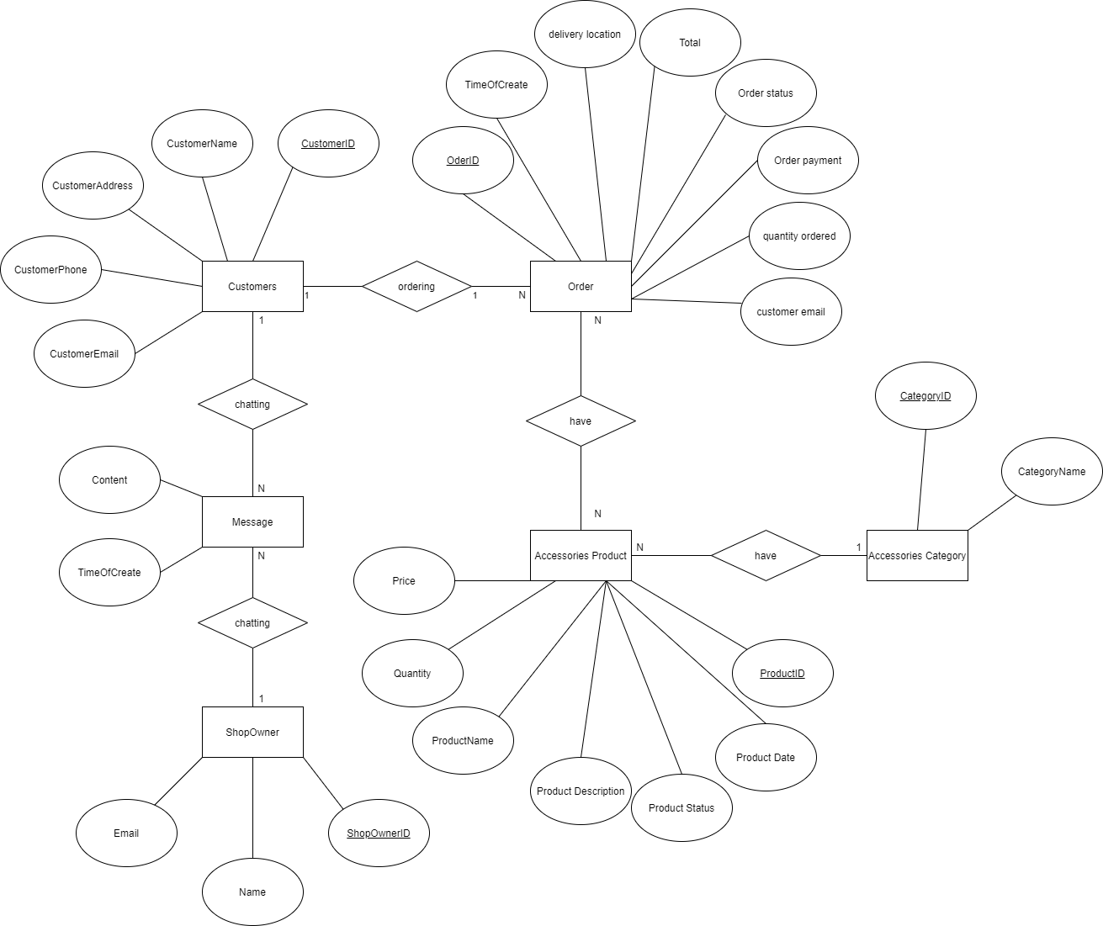

Figure . Partial data model for release 1.0 of the Car Accessories Store.

## Data Dictionary

|  |  |  |  |  |
| --- | --- | --- | --- | --- |
| Data Element | Description | Composition or Data Type | Length | Values |
| product ID | the product code of the order that the customer ordered | string | 100 |  |
| product date | the date the order will be delivered or received | date, MM/DD/YYYY | 10 | default = current date if the current time is before the order cutoff time, else the next day; cannot be prior to current date |
| product status | the status of the product where the customer has started to order | alphabetic | 16 | incomplete, accepted, prepared, pending delivery, delivered, canceled |
| quantity | the number of units of each product item that the Client is ordering in a single product order | integer | 4 | default = 1; maximum = quantity presently in inventory |
| product name | the name of the product the customer has ordered | string | 100 |  |
| product item price | the pre-tax cost of a single unit of a product item | numeric, dollars and cents | dd.cc |  |
| product item description | ext description of a product item on a list | alphabetic | 100 |  |

|  |  |  |  |  |
| --- | --- | --- | --- | --- |
| Data Element | Description | Composition or Data Type | Length | Values |
| delivery location | building and room to which an ordered meal is to be delivered | alphanumeric | 50 | hyphens and commas permitted |
| order ID | The ID of the order of the customer who ordered | string | 100 |  |
| order date | the date the order will be delivered or received | date, MM/DD/YYYY | 10 | default = current date if the current time is before the order cutoff time, else the next day; cannot be prior to current date |
| order status | the status of the order where the customer has started | alphabetic | 16 | incomplete, accepted, prepared, pending delivery, delivered, canceled |
| order payment | information about a payment COS accepted for a product item order | payment amount  + payment method  + transaction number |  |  |
| customer email | the email address of the client who placed a product order | alphanumeric | 50 |  |
| quantity ordered | the number of units of each product item that the Client is ordering in a single product order | integer | 4 | default = 1; maximum = quantity presently in inventory |

## Reports

### Ordered Meal History Report

|  |  |
| --- | --- |
| Report ID: | COS-RPT-1 |
| Report Title: | Ordered Meal History |
| Report Purpose: | Patron wants to see a list of all meals that he had previously ordered from the Process Impact cafeteria or local restaurants over a specified time period up to six months prior to the current date, so he can reorder a particular meal he liked. |
| Priority: | Medium |
| Report Users: | Patrons |
| Data Sources: | Database of previously placed meal orders |
| Frequency and Disposition; | Report is generated on demand by a Patron. Data in the report is static. Report is displayed on user's web browser screen on a computer, tablet, or smartphone. It can be printed if the display device permits printing. |
| Latency: | Complete report must be displayed to Patron within 3 seconds after it is requested. |
| Visual Layout: | Landscape mode |
| Header and Footer: | Report header shall contain the report title, Patron's name, and date range specified. If printed, report footer shall show the page number. |
| Report Body: | Fields shown and column headings:   * Order Number * Meal Date * Ordered From ("Cafeteria" or restaurant name) * Items ordered (list all items in the meal order, their quantity, and their prices) * Total Food Price * Tax * Delivery Charge * Total Price (sum of food item prices, tax, and delivery charge)   Selection Criteria: date range specified by Patron, inclusive of end points  Sort Criteria: reverse chronological order |
| End-of-Report Indicator: | None |
| Interactivity: | Patron can drill down to see ingredients and nutritional information for each item in the order |
| Security Access Restrictions: | A Patron may retrieve only his own meal order history |

[Note: Other COS reports are not provided in this example.]

## Data Integrity, Retention, and Disposal

DI-1: The COS shall retain Individual Patron meal orders for 6 months following the meal's delivery date.

DI-2: The COS shall retain menus for one year following the menu date.

# External Interface Requirements

## User Interfaces

UI-1: The Car Accessories Store screen displays shall conform to the Process Impact Internet Application User Interface Standard

UI-2:The web pages shall permit complete navigation and product item selection by using the keyboard alone, in addition to using mouse and keyboard combinations.

## Software Interfaces

SI-1: Accessories inventory System

SI-1.1: AOS shall poll the Accessories Inventory System to determine whether a requested accessories item is available.

SI-1.2: When the Accessories Inventory System notifies the AOS that a specific accessories item is no longer available, the AOS shall display sold in the menu.

## Hardware Interfaces

No hardware interfaces have been identified.

# Quality Attributes

## Usability Requirements

USE-1: 99% of new users shall be able to successfully order a accessories product without errors on their first try.

USE-2: The ACS shall allow customer to retrieve the previous accessories ordered with a single interaction.

## Performance Requirements

PER-1: The system shall accommodate a total of 500.000 users and a maximum of 1000 concurrent users .

PER-2: 95% of webpages generated by the ACS shall download completely within 4 seconds from the user requests the page over a 20Mbps or faster Internet connection.

PER-3:The system shall display confirmation messages to users within an average of 3 seconds and a maximum of 6 seconds after the user submits information to the system.

## Security Requirements

SEC-1: All network transactions that involve financial information or personally identifiable information shall be encrypted per BR-33.

SEC-2: Users shall be required to log on to the ACS for all operations except viewing a menu.

SEC-3: Only authorized Menu Managers shall be permitted to work with menus, per BR-24.

SEC-4: The system shall permit Patrons to view only orders that they placed.

## Safety Requirements

SAF-1: Users will be able to test product ingredients before receiving goods.

## Availability Requirements

AVL-1: The ACS shall be available at least 98% of the time between 5:00 A.M. and midnight local time and at least 90% of the time between midnight and 5:00 A.M. local time, excluding scheduled maintenance windows.

## Robustness Requirements

ROB-1: If the connection between the user and the ACS is broken prior to a new order being either confirmed or terminated, the ACS shall enable the user to recover an incomplete order and continue working on it.



